Pagemark Package Overview
Version 1.0.0
Revision 1.1

Pagemark — Package Overview
Version 1.0.0 · for readers outside the project. Three tiers: read the first for the idea, the second for what it does, the third for how it works.

Tier 1 — Simple
What it is. Pagemark is an app for your phone that keeps a diary of the books you read and listen to. For each book you note what you thought, give it a star rating, and track how far you've got. You can look books up by title or by scanning the barcode on the back.
What it's for. Remembering. Which book was that? Did I like it? When did I finish it? It works for any kind of book — fantasy, romance, science, anything — and for audiobooks as well as print. It also helps you plan: a list of what to read next, a note of who you lent a book to, and a calendar of the days you read.
What makes it different.
- It is private. Everything stays on your phone. There's no account to make, no ads, no tracking and no AI inside the app. A page in the app, "Our promise to you", says so in plain words, and the project's tests fail if the app stops keeping the promise.
- It has a hidden shelf for books you'd rather keep to yourself, locked with a PIN or your fingerprint.
- It is made for people who don't want to learn software: plain words, a short guide inside the app, sample books to try, and reminders to save a backup.
- It's free, and it uses only free sources for book information.
How you'd use it. Install it, tap *Add book*, scan or search, and start logging. Once a year, look at the *Stats* tab for your year in books and share the picture if you like.

Tier 2 — Medium
Purpose. A local-first reading tracker for Android (iOS planned). It replaces cloud services such as Goodreads with a log you fully own, including audiobooks and a private vault.
Main capabilities
Area | What you get
Capture | Search Open Library and Google Books together (switchable), look up by ISBN, scan barcodes one by one or a whole shelf, add by hand; duplicate warning; refresh a book's details and pick another edition
Logging | Multiple *reads* per book (print / e-book / audio); status, dates, half-star rating, optional detailed ratings (story, characters, writing, pace, feeling, narrator), private thoughts, time
Progress | Current page, progress bars, pages per day, estimated days left, and a reading timer with a saved history
Organise | Shelves (many per book), series with numbers and totals, tags, filters, sort, "Currently reading" strip, a "read next" order with suggestions from your own list, lending notes with a reminder
Library looks | Classic list, cover wall, bookshelf, book spines, compact — switchable, remembered per library; side-by-side Library and book on tablets
Insight | Yearly goal ring with pace forecast, "Days you read" calendar, a shareable "Year in books" picture and a printable PDF report, books per month, rating spread, top genres and authors, totals
Privacy | Locked library (PIN with attempt limits and recovery code, or device biometrics), auto-relock with a configurable delay, an optional whole-app lock, screenshot blocking
Quotes & covers | Save passages with pages and stars; save covers on the phone for offline use and backups; author pages
Import / export | Goodreads, StoryGraph and Pagemark files in, with a preview, duplicate handling, a safety copy and Undo; CSV and JSON out
Backup | Password-protected (AES-256) backup file or spreadsheet saved wherever the user chooses; automatic backups into a folder (including one inside Google Drive, OneDrive or Dropbox) through Android's own picker; a "time to back up" reminder; safe restore with automatic restore points
Care | Trash with 30-day recovery, in-app updates with release notes, offline version history, plain-words diagnostics log
Reach | Home-screen widget, icon shortcuts, Share to Pagemark, reminders
Look | Six named themes (Harbor, Midnight Ink, Rosewater, Plum Velvet, Sage, Lamplight); large text and display size tested; a screen-reader-friendly star control

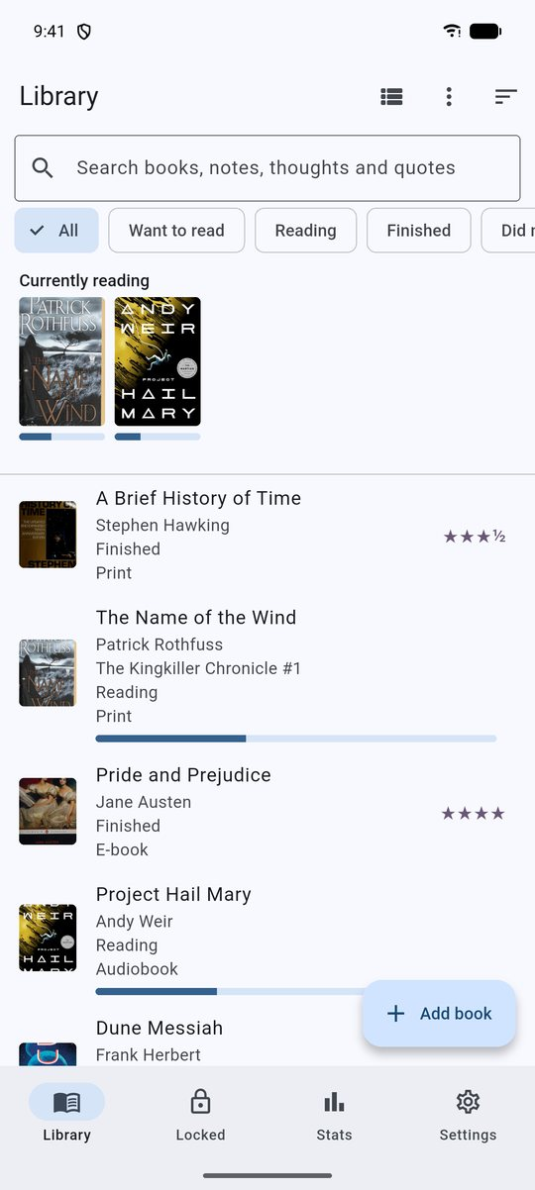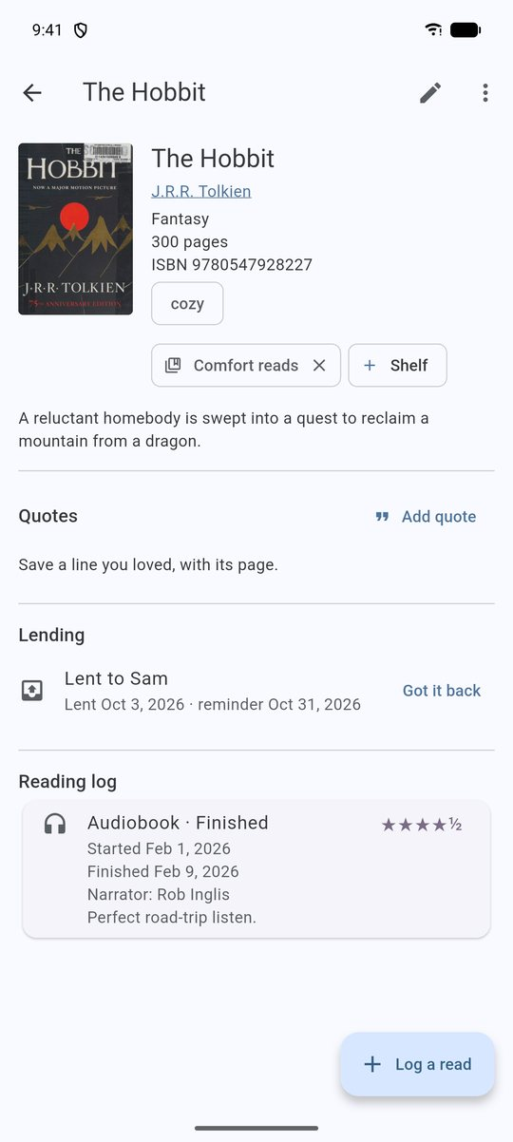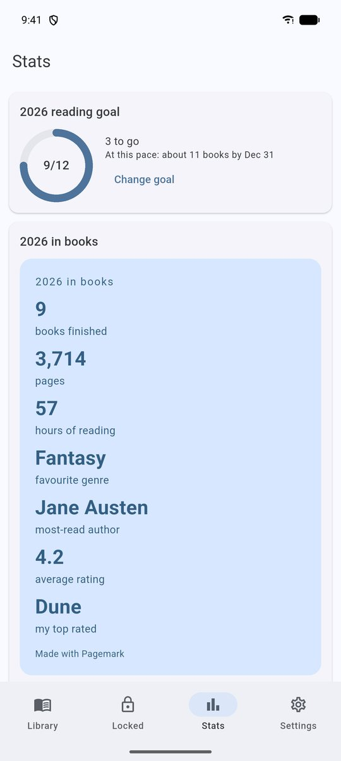
Library · Book page · Stats
Principles. No accounts, no analytics, no ads, no paid services, no AI inside the app. The network is used for book lookup (Open Library and Google Books), cover pictures, and — in the GitHub version only — the update check.
Who it's for. Readers who want a durable, private record; people leaving other tracking sites; anyone who wants their data in a plain file they can open elsewhere; and people who find most apps too fussy.
Distribution. Free APKs on GitHub Releases (MIT-licensed source in a public repository). In-app updates install over the old version and keep your data. A Google Play version is being prepared.

Tier 3 — Advanced

Stack
Flutter 3.47 (Dart) app, about 16,000 lines, with a little Kotlin for the home-screen widget, the share and shortcut intents, and the Android folder picker. Drift over SQLite for storage; plain StatefulWidgets with database streams (no state-management package); flutter_secure_storage for secrets; cryptography for PBKDF2 and AES-GCM; flutter_local_notifications with timezone for reminders; home_widget for the widget; http for Open Library, Google Books and GitHub; mobile_scanner for barcodes; local_auth for biometrics; pdf to build the yearly report on the phone; share_plus, file_picker, archive for sharing, restore and zip backups. lib/ui.dart is one library split into part files; wide-screen layout helpers live in lib/adaptive.dart.

Data model (schema 6)
- books — catalog entry: title, author, ISBN-13, cover URL, genre, series, seriesNumber, seriesTotal, publisher, year, pages, description, tags, notes, locked, added, deletedAt (soft delete), queuePos (read-next order).
- reads — one read-through: format, status, started/finished, rating (0.5–5), optional aspect ratings, thoughts, narrator, minutes, currentPage, optional heat and content notes; FK to books with cascade.
- quotes (with a star rating), shelves, book_shelves (many-to-many).
- reading_sessions — one timer sitting: book, day, minutes, pages.
- loans — who has a book, lent date, optional reminder date, returned date.
- Indexes on the hot columns. WAL journal, 5 s busy timeout, foreign_keys=ON in beforeOpen. Versioned migrations 1→6; every historic schema (built by the code of the matching release) is migrated and checked in an audit script. Migrations guard later addColumn steps so a table created by an old step with the current definition is never altered twice.

Privacy and security design
- Vault is a flag, not a second database, enforced at every read path: library queries, Stats, the year card, the PDF report, the calendar, suggestions, Trash, duplicate check, the home-screen widget and CSV/JSON export all filter on locked. Full database backups include it by design and can be encrypted.
- PIN: PBKDF2-HMAC-SHA256, 150 000 iterations, random 16-byte salt, constant-time compare, persistent attempt counter with exponential lockout (30 s doubling, cap 1 h). One-time recovery code stored only as a PBKDF2 hash.
- Vault lifecycle: on background/leave the app pops locked routes, empties the locked-cover cache and deletes temporary exports; FLAG_SECURE is set while the vault is open so the recents thumbnail is blank. On a tablet the two-pane view is never used for the Locked library.
- Backups: container PGMKENC1 | salt | nonce | AES-256-GCM ciphertext | tag, key from PBKDF2. Folder backups use Android's Storage Access Framework (no storage permission), run when the app opens and one is due, keep the newest 5 and only commit the chosen folder after the password question.
- Restore: open the candidate read-only, PRAGMA integrity_check, require books/reads, reject newer schemas, snapshot the current database as a restore point (newest 3 kept), close the connection, delete -wal/-shm, rename the staged copy into place; the app restarts.
- Android: allowBackup=false plus data-extraction rules exclude everything; no analytics SDKs; scheduled-notification receivers declared (and guarded by a test); release builds are signed with APK Signature Scheme v2 and v3; native libraries are 16 KB aligned.

Networking
Open Library search, ISBN, works and editions endpoints and Google Books volumes (no key) with an identifying User-Agent, retry with backoff on 429/5xx/timeouts, per-record fault tolerance, ISBN-10→13 normalisation and checksum validation, page and year bounds, and a merge that only fills gaps. Updates (GitHub flavour only) use the unauthenticated GitHub releases API: newest-first list → APK chosen by ABI → streamed download with size and SHA-256 verification → system installer. A test lists every host the app may contact and fails if a new one appears without a line on the promise page. The barcode reader uses Google's on-device ML Kit; the promise page says so.

Quality and process
- About 300 automated tests: database behaviour and migrations, restore validation, export safety, encryption round-trip and tamper detection, lock service, lookup parsing and retries (mock HTTP), merge and refresh logic, reading-life logic (streaks, year summary, queue, loans, PDF), layout and accessibility checks at 200% text, guide-to-app consistency, promise honesty (banned packages, allowed hosts) and an encoding guard.
- Independent audits: a pre-release audit (0.7.0, 84 findings, all fixed), a 1.0.0 gate audit of 0.13.0, a mobile audit (MASVS and Play compliance), and a hands-on test of 0.13.1 on a Galaxy S25 Ultra (70 passed, 13 failed, 10 skipped; every app problem found has a fix, including reminders that never appeared because of a missing manifest entry). Reports are kept in Documentation/ and docs/release-audit/.
- GitHub Actions CI: analyze, tests, generated-code check, debug builds of both flavors. Signed release APKs and the Play bundle are built locally with tool/build.ps1; the keystore never leaves the owner's machine.
- Release flow: version bump + CHANGELOG.md in one commit → tag vX.Y.Z → APKs (arm64, armv7) attached to a GitHub Release. The changelog ships inside the app as an asset.

Known limits
- The library file is not separately encrypted by the app (a deliberate choice: Android already isolates and encrypts app storage, and an on-phone key adds little). Exports and backups can be passphrase-encrypted.
- Backups are saved by the user or into a folder the user picks; there is no Pagemark cloud. Reminders use inexact alarms and may arrive a few minutes late on phones with aggressive battery managers.
- English only; no iOS build yet (the project is configured; it needs a Mac to build and sign).
- Book data quality depends on the free sources (genres and editions can be noisy; Refresh details lets the user correct them). The PDF report uses built-in fonts, so letters outside Western European ones print as ?.
- TalkBack has been designed for but tested less than the rest.
- Release builds are shrunk with R8; the mapping file stays with the owner.

Roadmap highlights
A second interface language, the Google Play release (closed test first), then iOS.

